# Learning UML 2.0

## Introduction

### Example

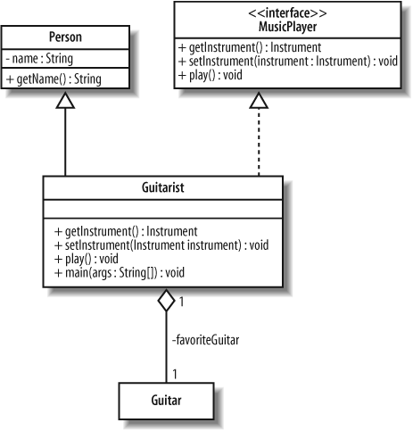

### Degree of UML

As a sketch

As a blueprint

As a programming language

Stereotypes signify a special use or intent and can be applied to almost any element of UML notation.

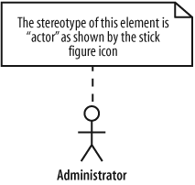 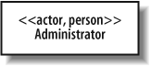

Note the administrator is an actor and a person

Standard stereotypes include

Utility

### Service

Subsystem

Executable

File

Library

Source

### Tagged values

Stereotypes can contain extra information that relates to the element to which they are applied

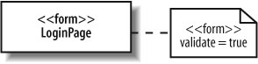

## Modelling requirements: use cases

Use cases are at heart of your model

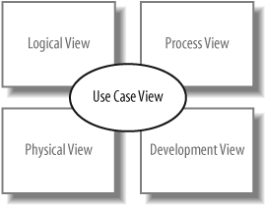

Actors

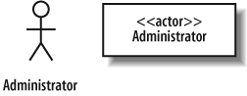

Questions to ask for identifying an actor

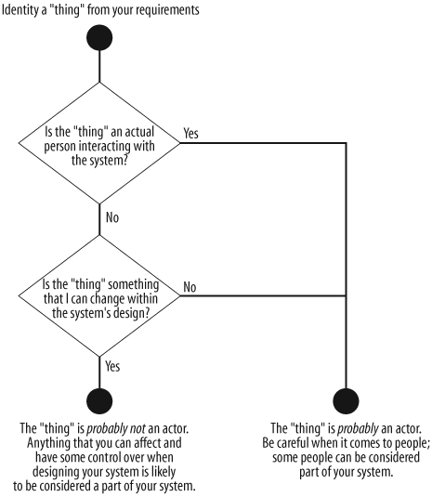

Use cases and communication lines

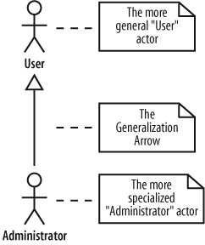

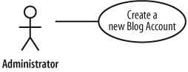

System boundaries

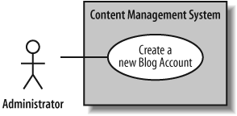

Information can be included in use case description

Description detail

Related requirements

Goal in context

Preconditions

Successful end condition

Failed end condition

Primary actors

Secondary actors

Trigger

Main flow

Extensions

### Use case relationships

The <<include>> relationship

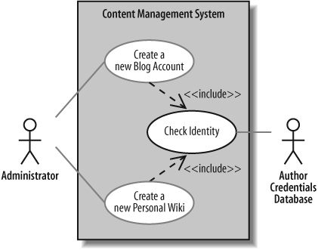

Special cases, example create regular blog account

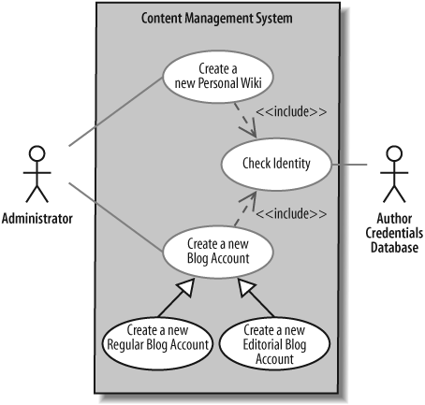

The <<extend>> relationship, a means for you to show that a use case might completely reuse another use case’s behavior

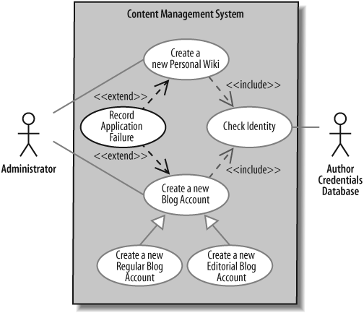

Use case overview diagrams

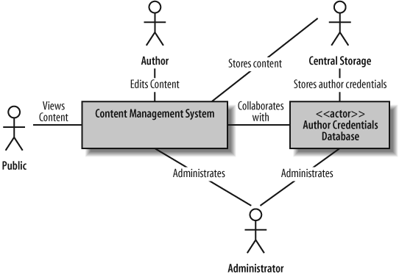

## Activity diagram

Example, flow the use case flow

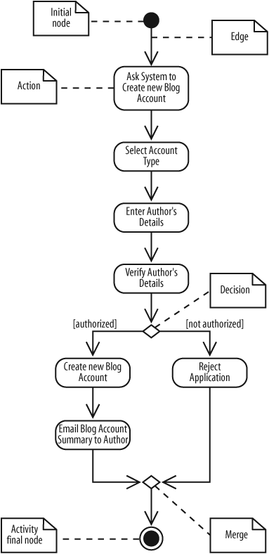

Multiple tasks at same time

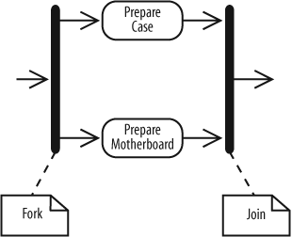

Time events

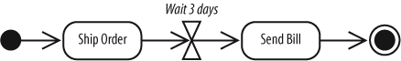

Call another activity

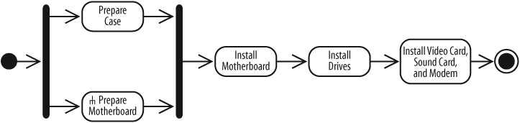

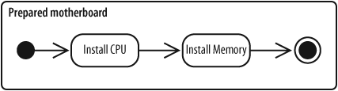

Showing objects passed between actions

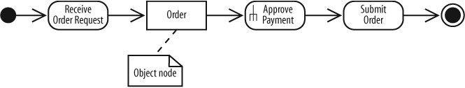

Showing action inputs and outputs

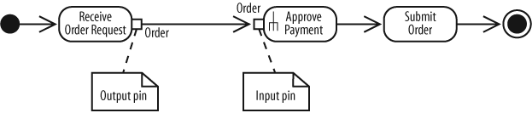

Showing how objects change state during an activity

The focus of this diagram is the change of state of the Order object throughout the order approval process

Sending and receiving signals

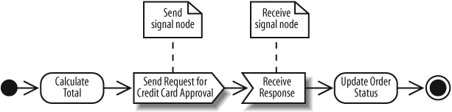

Interrupting an activity, a process that can be interrupted

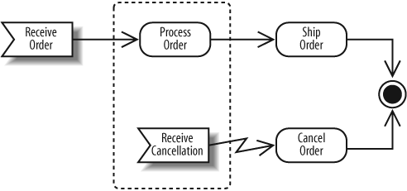

Partitions or swimlanes, activities may involve different participants

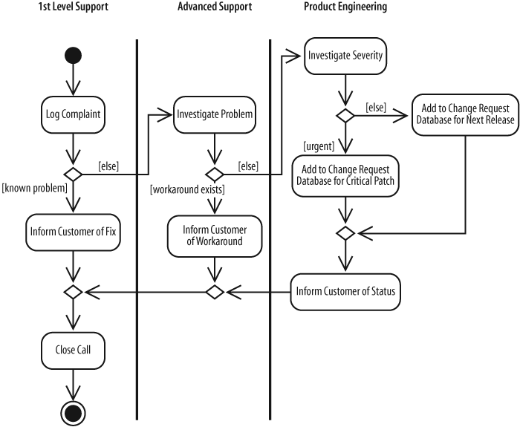

Connectors help untangle your diagrams, connecting edges with symbols instead of explicit lines.

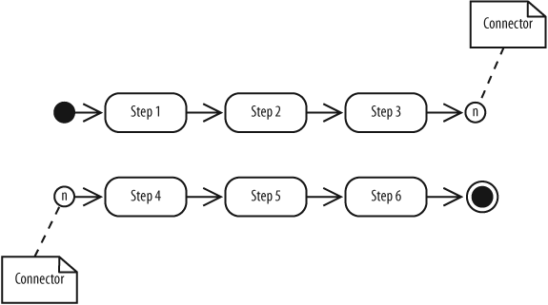

Expansion regions show that actions in a region are performed for each item in an input collection

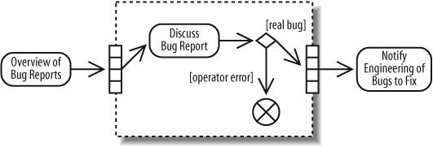

## Modeling a system’s logical structure introducing classes and class diagrams

Abstraction

Encapsulation

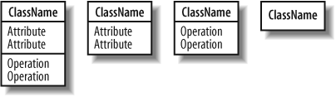

Visibility

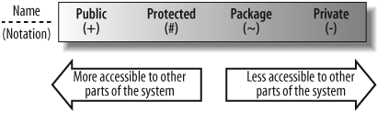

Multiplicity allows you specify that an attribute represents a collection of objects

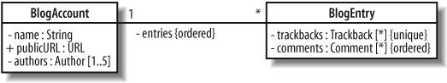

Readonly property applied

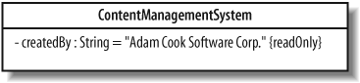

### Inline attributes versus attributes by association

Association

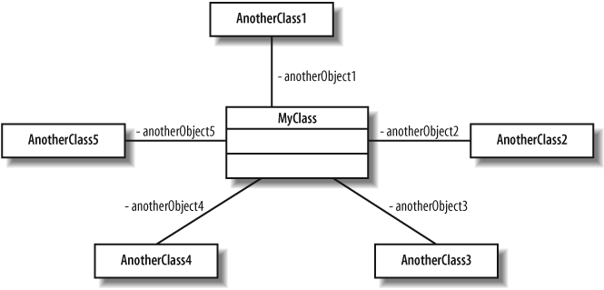

Inline

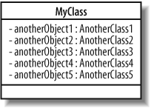

### Class behavior operations

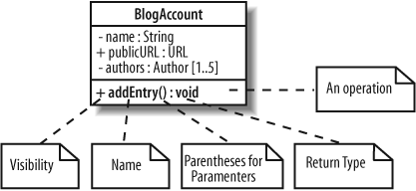

Parameters and return type

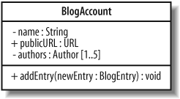

## Modeling a system’s logical structure

Class relationships

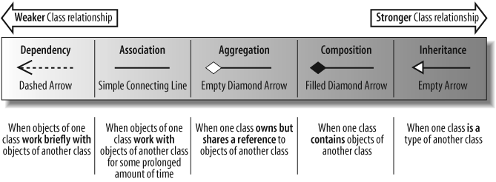

Dependency

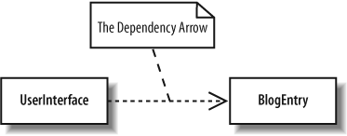

Association

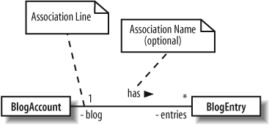

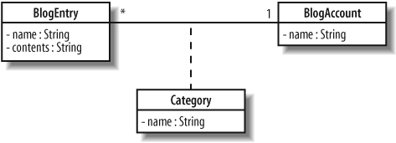

Aggregation, a class owns but may share objects of another class

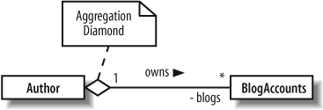

Composition, stronger relationship than aggregation

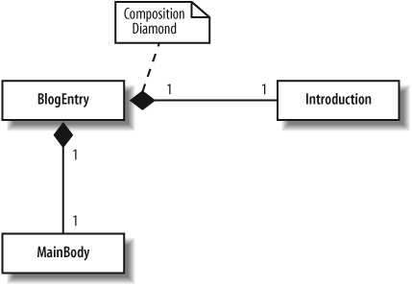

Generalization, otherwise known as inheritance

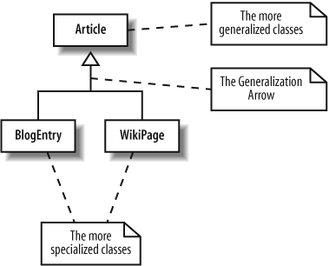

Multiple inheritance

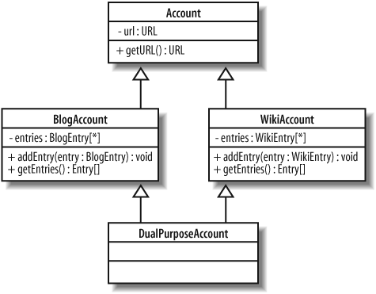

Constraints

Invariants, a constraint that must always be true

Preconditions, is a constraint that is defined on a method and is checked before the method executes

Postconditions, defined on a method, is check after the method executes

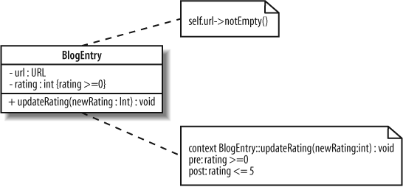

Abstract class

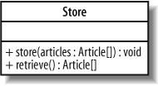

Interface

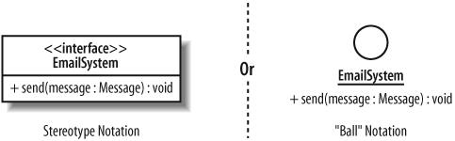

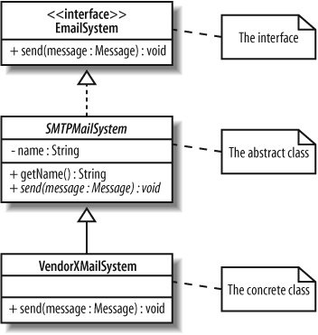

Templates, parameterized with the type referred to as E. There is no class in our model called E

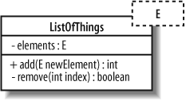

# Bring your classes to life, object diagrams

It helps to capture the logical view of your model

Object instances

The entry object is an instance of the BlogEntry class from Chapter 4

Anonymous object

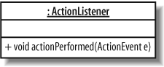

Links, objects on their own are not very interesting or helpful. Work together at runtime configuration

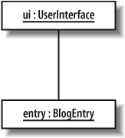

Links and constraints

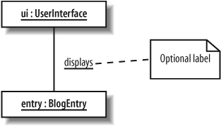

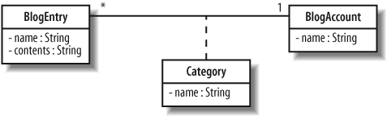

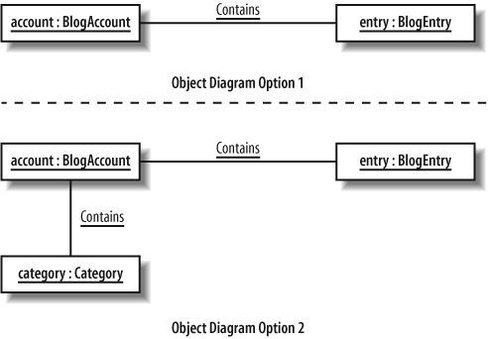

Binding class template

The listOfBlogEntries reuses the generic ListOfThings template, binding the E parameter to the BlogEntry class to store only objects of the BlogEntry class

## Modeling ordered interaction, sequence diagrams

Participants in a sequence diagram

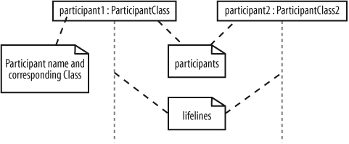

Time, events, signals, activation bars and messages

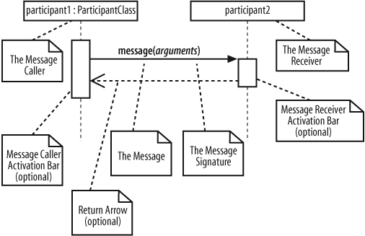

Nested messages

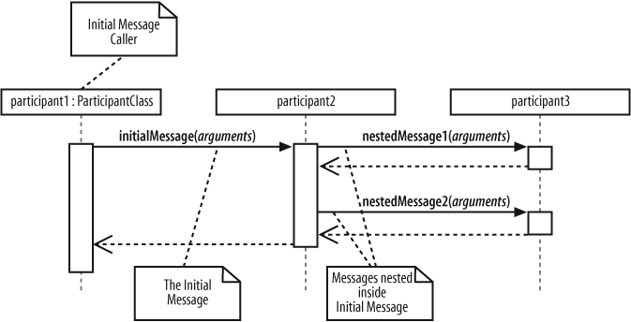

Message arrows

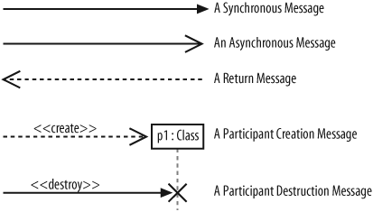

Example a live sequence diagram

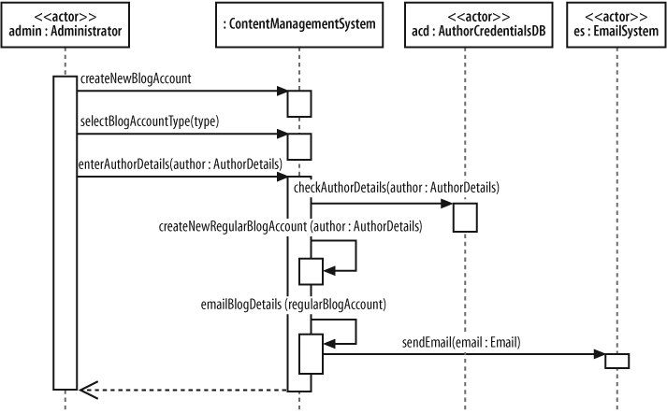

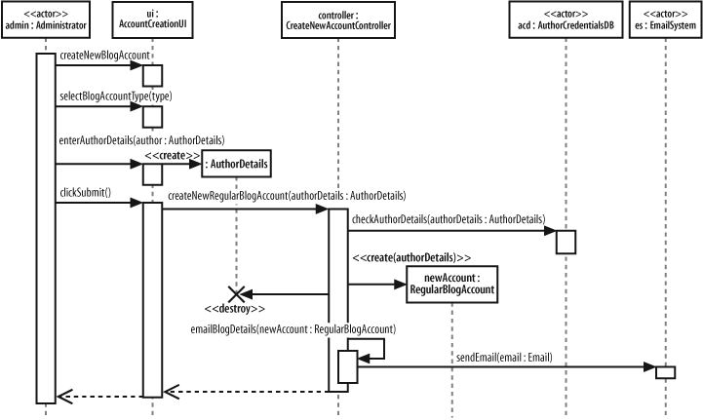

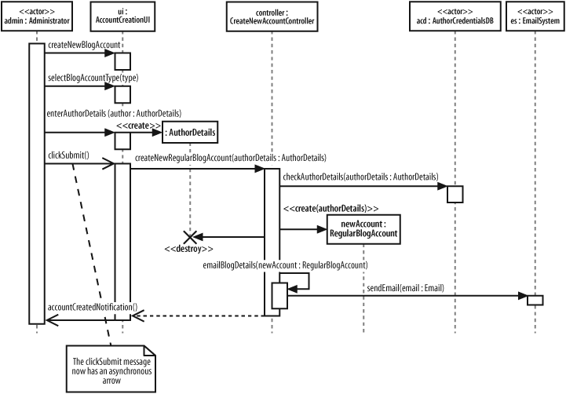

Managing complex interactions with sequence fragments, which means that this is an optional fragment. All the interactions contained within the fragment box

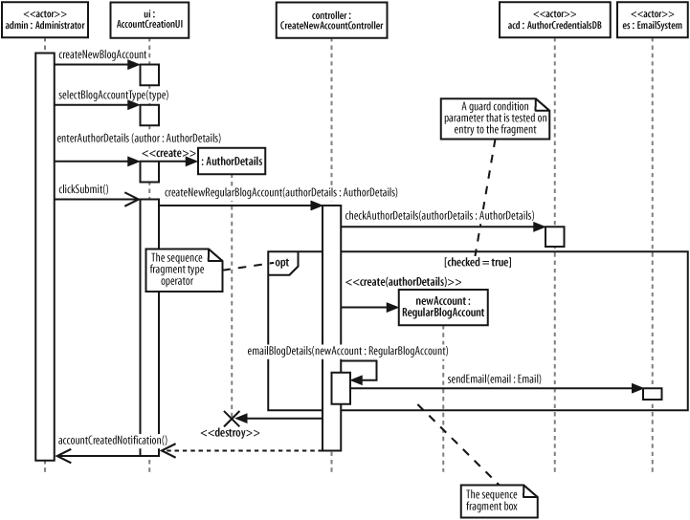

UML2.0’s fragment types

Ref , Represents an interaction that is defined elsewhere in the model

Assert, condition must be occurred exactly as they are indicated

Loop,

Break

Alt, like switch

Opt, execute only if the guard condition evaluates to true

Neg, declares that the interactions inside this fragment are not to be executed

Par, specifies that interactions within this fragment can happily execute in parallel.

Region, Interactions within this type of fragment are said to be part of a critical region

## Focusing on interaction links

Participants, links and messages

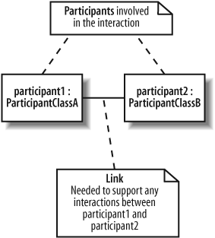

A message on a communication diagram

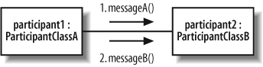

Invoke message multiple times

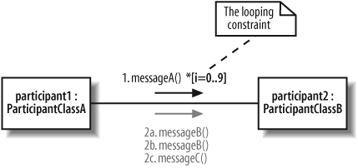

Add condition

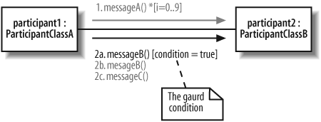

Message to a participant itself

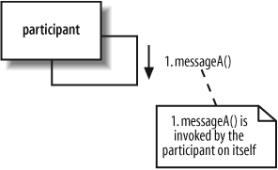

Fleshing out an interaction with a communication diagram, example. Compare communication and sequence diagram

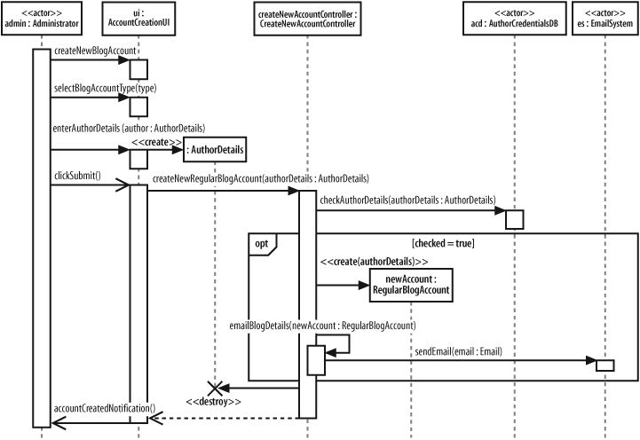

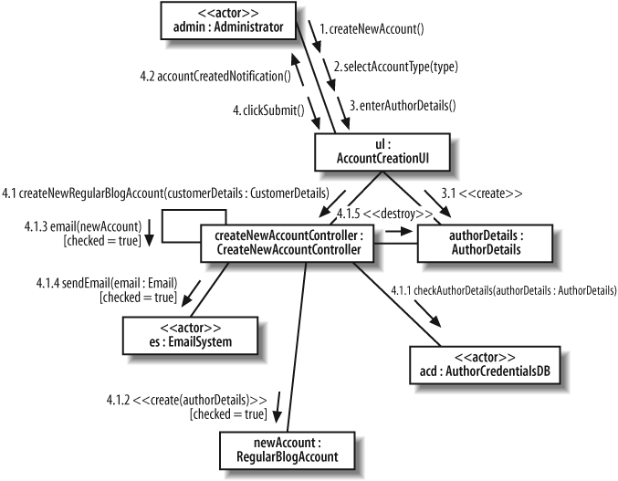

## Focusing on interaction timing, timing diagram

### Participations, states, timeline, constraint

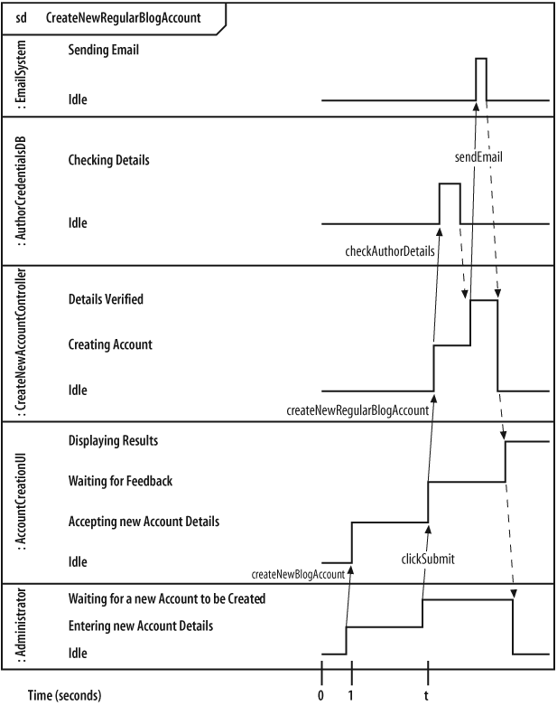

Time diagram can be converted from communication diagram etc.

An alternative notation

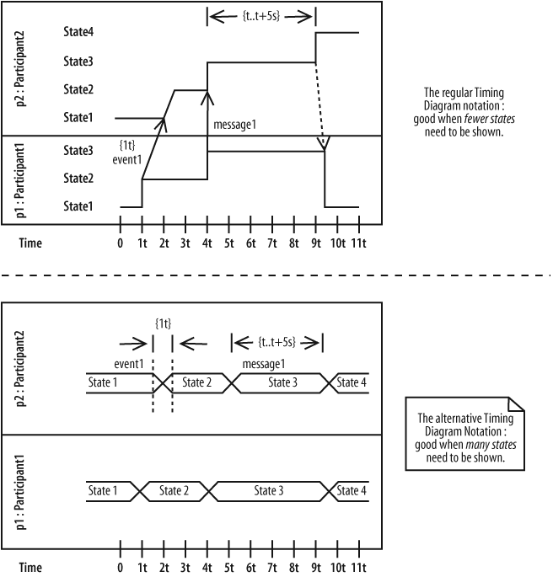

## Completing the interaction picture, interaction overview diagrams

Parts of an interaction overview

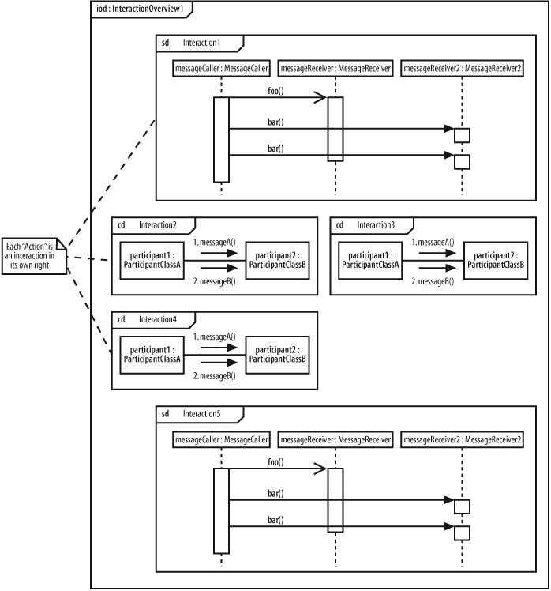

Modeling a use case using an interaction overview

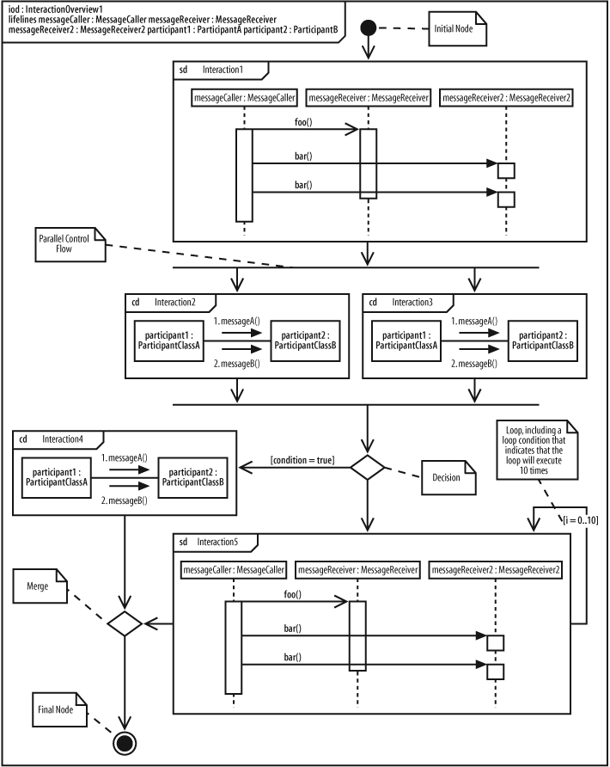

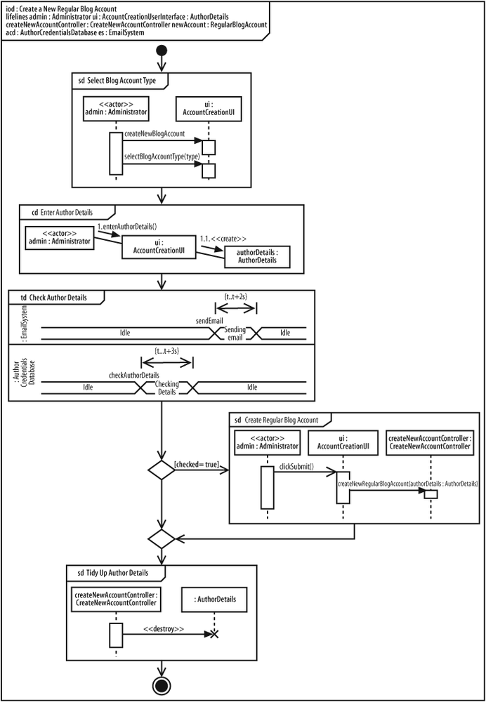

Managing and reusing your system’s parts

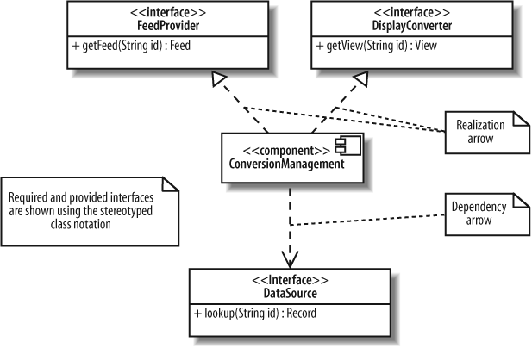

Showing components working together

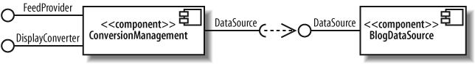

Focusing on the key components and interfaces in your system

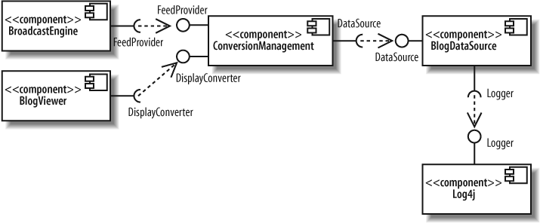

Classes that realize a component

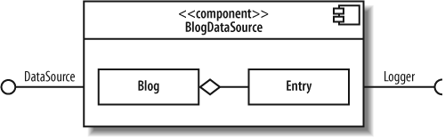

Alternate view, showing the realizing classes

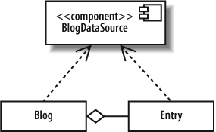

Delegation connectors show how interfaces correspond to internal parts

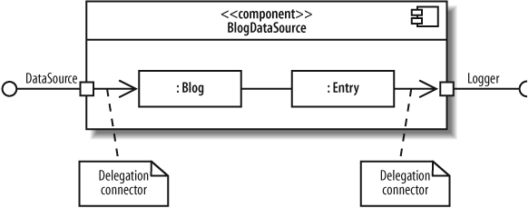

Black box and white box component view

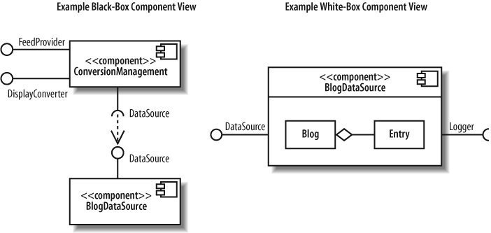

## Organize your model

### Packages

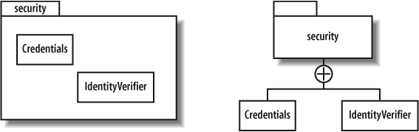

Nested packages

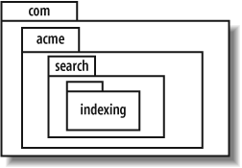

Namespace reference each other

Representing a class with its fully-scoped name: both the security and utils packages have a class named Credentials

Element visibility

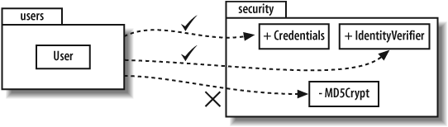

Package dependency

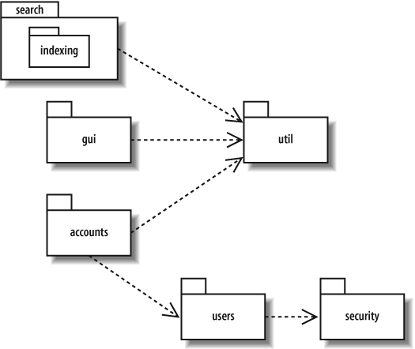

Importing packages

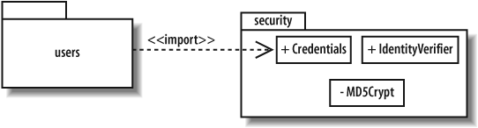

Packages diagram to organize use case

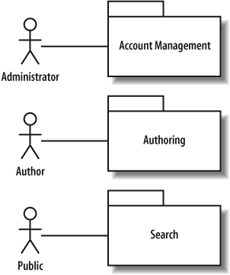

## Modeling an object’s state, state machine diagram

### Essentials

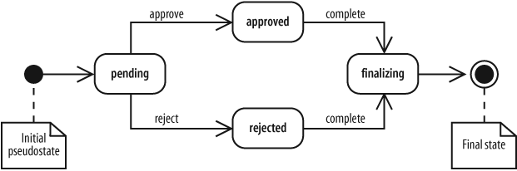

States

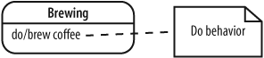

### Transitions, represents a change of states from a source state to a target state . A transition description, written along the arrow

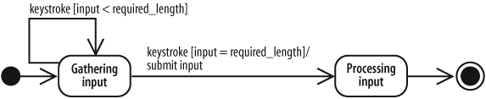

### Advanced state behavior

Internal state

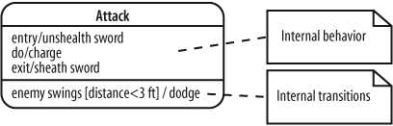

### Composite states

UML allows concurrent states, or being in multiple states at the same time.

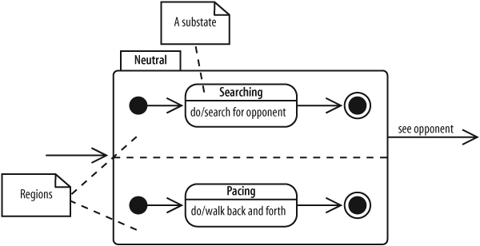

Advanced pseudo states

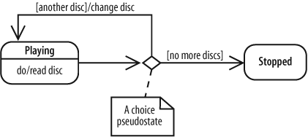

Forks and joins concurrent states

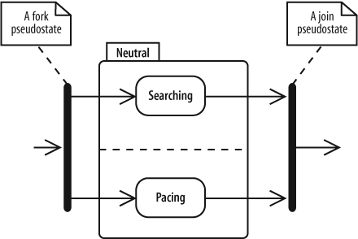

Signals

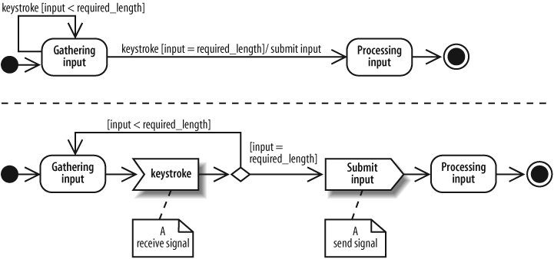

## Deployed system diagrams

Hardware execution environment

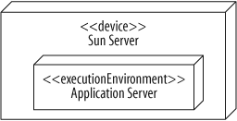

A node is a hardware or software resource that can host software or related files.

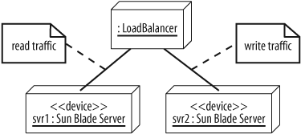

Communication between nodes

A Desktop PC and Server communicate via TCP/IP

Deployment specification

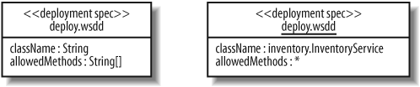

Provide physical design of the system

